**Web based Online Food Ordering System**

BITS ZC229T: Design Project

by

**Bejagama Chandana**

**202217B2131**

Design Project work carried out at

HCL Technologies, Nagpur

Submitted in partial fulfilment of B.Sc. (Design and Computing) degree programme

Under the Supervision of

**Himanshu Jain**

HCL Tech, Nagpur



BIRLA INSTITUTE OF TECHNOLOGY & SCIENCE

PILANI (RAJASTHAN)

Sep 2024

**CERTIFICATE**

This is to endorse that the Design Project entitled Web based Oline Food Ordering System and presented by Bejagama Chandana with BITS ID No. 202217b2131, in partial fulfilment for the completion of B.Sc. (Design and Computing) degree course of BITS, is a Bonafide work carried out by him/her under my direction.

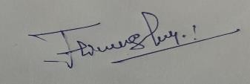

______________________

Mentor’s Signature

Himanshu Jain, HCL Technologies, Nagpur

**Key words:**

HTML,

CSS,

Java Script

**Project Areas:**

Web development

**ACKNOWLWDGEMENTS**

I would like to thank Himanshu Jain, Technical Lead at HCL Tech, Nagpur, for his warm support, useful information and guidance which enabled me to complete this project through various stages. I would also like to express my sincere gratitude to Faridha Chinthala, Senior Software Engineer. Her advises and support while working on the project allowed me to complete the mission successfully. I would also like to express my heartfelt appreciation to my friends and family for their encouragement and support in making this report a success.

ABSTACT

**Project Title**: Web based Online Food Ordering System

Order placement is one of the most essential activities in any food service establishment. Therefore, the purpose of this project is to come up with a more integrated online food ordering system specific to the food service industry. It will allow the restaurants to control online menus that can be accessed and ordered from the customers in the fastest and most efficient way possible. The customers will be able to choose one of the two alternatives provided. Online payment and cash on delivery will be the two alternatives. The client can view the products, register and place an order. Online Food Ordering is like an electronic shop that is primarily located on the seller computer connected through the internet. There are no agents. An Online Food Ordering System is contextualised here which ease the ordering of food. The system which is under consideration provides for a graphical user interface and also provides for the modification of the menu by including all the available options to ease the work of the customer. In addition, customer is able to place an order for more than one item at a time and also view their order summary.

Contents

1. INTRODUCTION: 4

2. OBJECTIVES 4

3.Description: 6

3.1 Description: 6

3.2Web Pages details: 6

3.3 Web Ordering System Module 6

3. Web Application: 7

4. Online Food Ordering System Website: 7

User Interface: 7

5.System Analysis: 14

6.Summary: 14

7. References and Bibliography: 14

8. Declaration by Student 16

# INTRODUCTION:

An online food ordering system that is internet based makes ordering food easier for customers and restaurant processes easier to manage on the whole. Users with this system can look at a menu, make their orders as per their preferences, and make payment over the web ensuring that, convenience is achieved and waiting time cut down. On the other hand, in an efficient manner, the system helps restaurants in handling the orders via an administrative interface which keeps the record of orders, inventory and customer details. Besides, this platform is very user-oriented as it allows to do all the above in real time, for example allowing the user to see the status of their order. Web-based food ordering systems such as marketing services to attract customers, collecting customer feedback, and offering discounts for the customers' best rate, positively influence the customers, the restaurant, and the ways of doing business in modern days. Today's e-commerce environment makes such system imperative.

## OBJECTIVES

The core goals of the web-based food ordering system are to improve customer satisfaction and streamline the processes in the restaurant. The system helps a user to save time and enhances user experience by allowing the user to view menus, place orders and even pay for the orders online. It seeks to reduce order mistakes by eradicating incidences of phone calls and imputing of order details by hand thus upholding the integrity of the order information. Another main goal is to enhance operational efficiency in the case of restaurants by easing the management of orders, therefore order processing, inventory control and staff management becomes easier.

The system also intends to enhance the sales by providing additional functionalities such as promotional discounts and targeted offers to the customers which increases loyalty and hence more orders. It is also helpful in understanding customers by providing information on what they like to order and the pattern of their consumption, thus making it easy for the restaurants to strategize in the market. To summarize this system is designed in a way that makes ordering appealing and convenient for the user as well as the restaurant.

nevitably, the introduction of online food ordering systems has been at the core of improving the relationship between restaurants and their clientele. In this case technology is utilized to ease work by expediting the processes of ordering for foodstuff that may be in ambitious states and having it delivered to a location. In other words, the main goals of an online food-ordering app would always be… convenience, accessibility, accuracy, and customer service. These attributes tend to be very important in the context of modern life which is highly dynamic and digitized.

In the first place, the system seeks to improve convenience of customers that allows them to view the menu and order and pay for food without having to go to the restaurant. This access at all times and at the comfort of one’s smartphone is most ideal at the moment so that it appeals to the services offered since all are fast paced.

Another central goal is to enhance the level of accessibility. If a system allows customers to order food regardless of their location, such system makes it possible for restaurants to order services from such systems and thus widen their market base. It bears no exclusivity even to the resident’s remote vicinity enabling the restaurant market extend incurring more possible revenues.

There are also other areas within these systems that are aimed at meeting an objective which in this case is accuracy and efficiency in the processes of events that are being ordered. E-ordering systems facilitate a reduction in the degree of human error by mechanizing the order placement stage so that there are no misplaced orders. This enhances speeding up the processing and the delivery of the right orders which in turn improves customer retention rates.

Lastly, a goal of a food ordering application is to provide easy patient monitoring for customer satisfaction and caters for specific needs of the users. Most of such systems offer real time tracking of order, customer segmentation, and developing loyalty which provide relevance and enhance enjoyment to users.

The aims of an internet based food ordering system can be summed up as: making it easier for customers to place food orders; improving the reach; bringing more accuracy in orders; and enhancing customer interaction. These objectives are the reason why it is a critical system for any restaurant that seeks to be truly successful in this day and age.

## 3.Description:

## 3.1 Description:

* User can login
* While logging user needs to provide his/her Email and Password.
* If the user is having the account he/she can sign in with the Email and Password.
* User can go the home page and can check menu which are present in our website.
* User can select number of food items he/she wants.
* Once user selects those food items then user can click on add to cart button.
* Add to cart page shows the food items that user has selected in menu page.
* Once User clicks on Proceed to Checkout button, then it goes to Billing page.
* In Billing Page, it shows the total amount of food items.
* User can select any one of payment: COD or G pay or Phonepe.
* Admin has to login with his Credentials
* Admin can able to see the order details of user.
* If any support from us user can also use contact us page.

## 3.2Web Pages details:

The Application involves:

* Login Form
* Signup Form
* Home Page
* Menu
* Add to Cart
* Billing Summary
* Admin Login Page
* Order details Page in Admin
* Contact Us
* Logout Page

## 3.3 Web Ordering System Module

User can follow below steps to order food

* Create an account.
* If the user is already having an account, then sign up.
* Navigate to the welcome page.
* Once login then the user goes to home page.
* In home page User can check menu of our website.
* If the User selects food items from menu, then he/she can click add to cart page.
* In add to cart page User can able to see the food items he/she selects from menu.
* Once user click on proceed to checkout button, then he/she can able to pay bill successfully with 3 payment options.
* If he/she is an Admin, then login to Admin page
* Admin is able to see the Order details of a user.
* If any support required from us then user can go to Contact Us page.

# 3. Web Application:

Hypertext Markup Language

User Interface

Cascading Style Sheets

Java Script

# 4. Online Food Ordering System Website:

### User Interface:

**Welcome Page:**

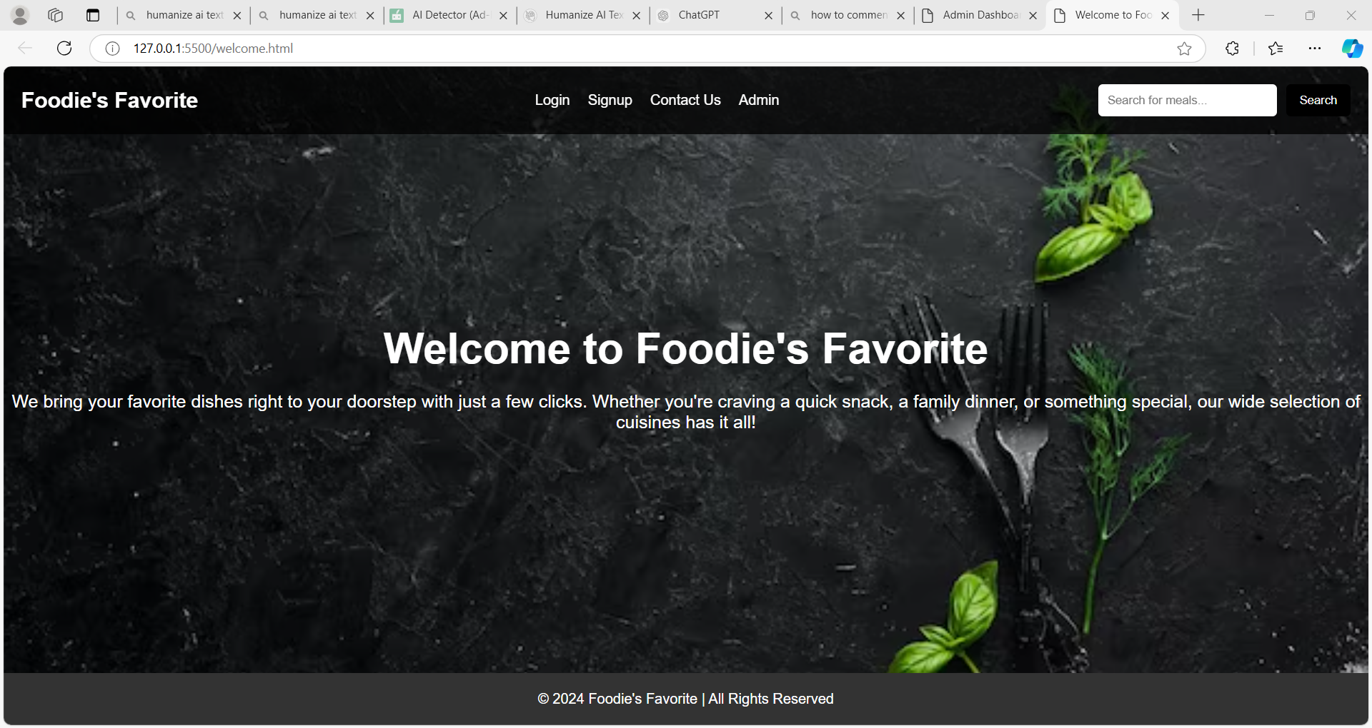

**Login Page:**

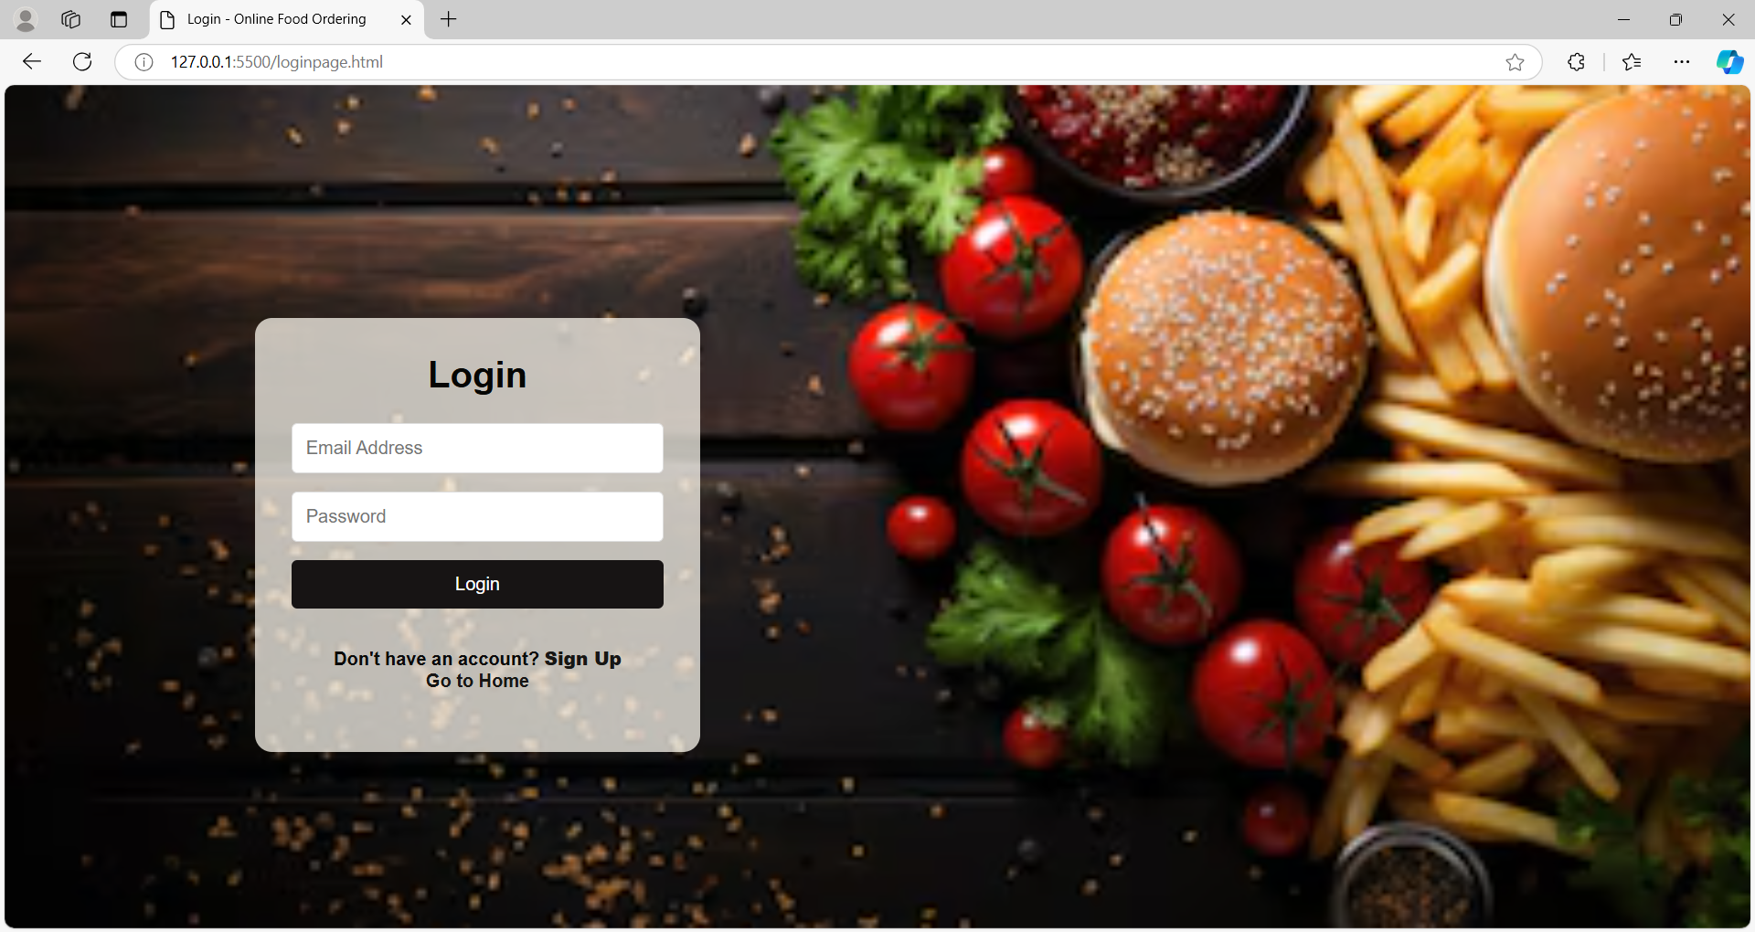

**Signup Page:**

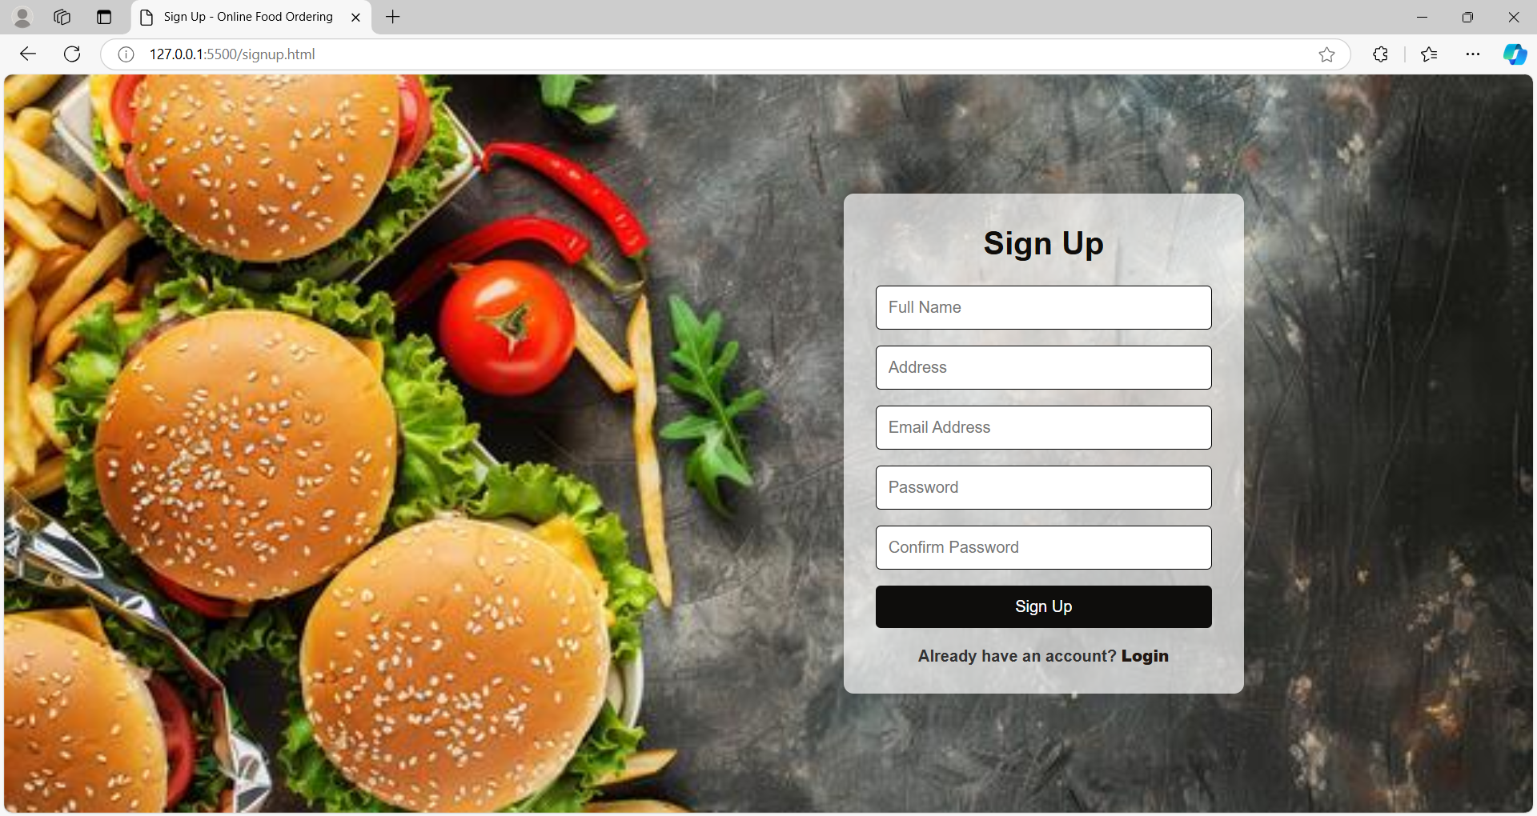

**Home Page:**

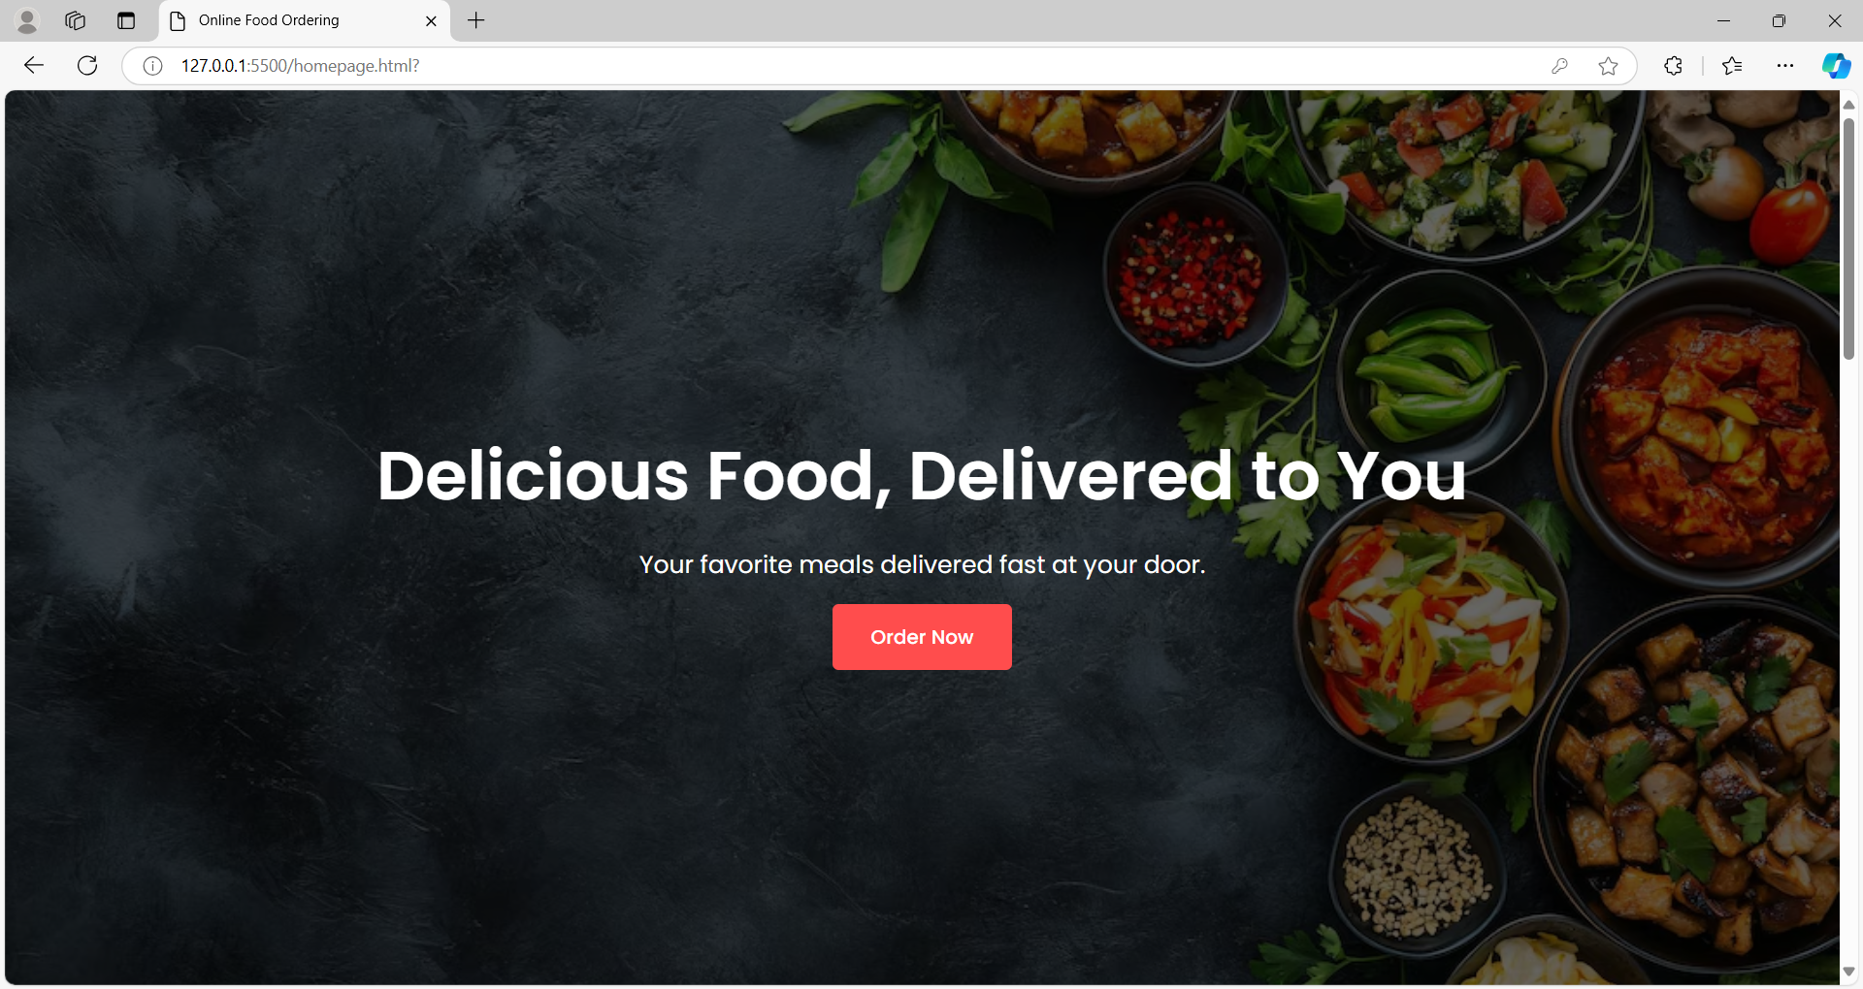

**Menu:**

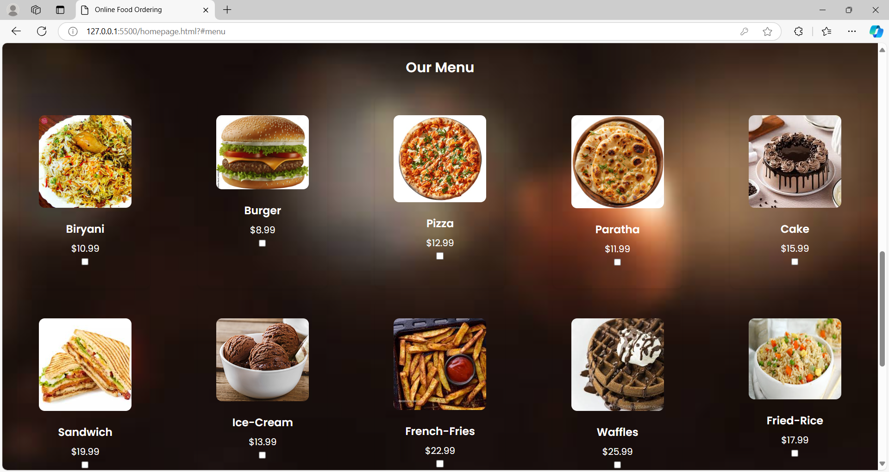

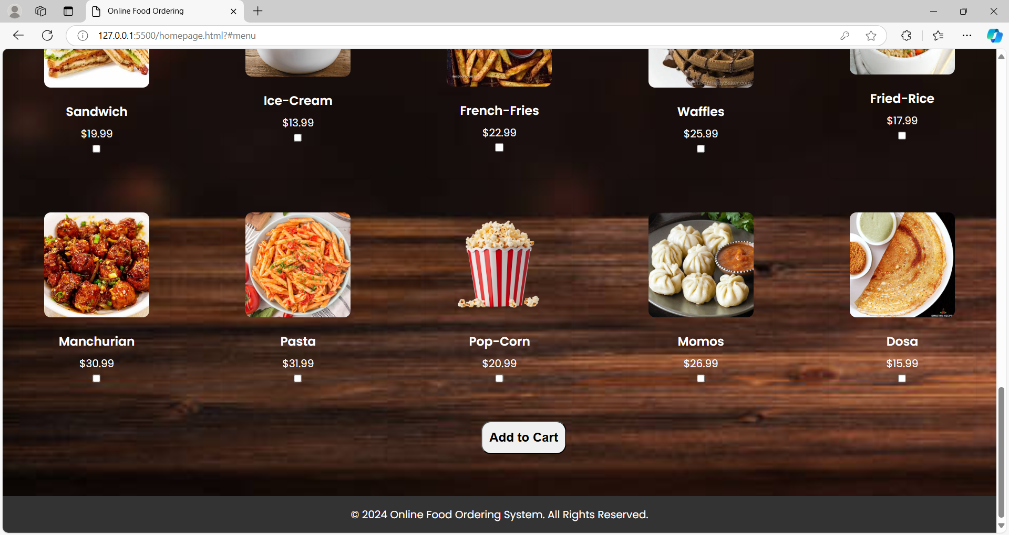

**Add to cart Page:**

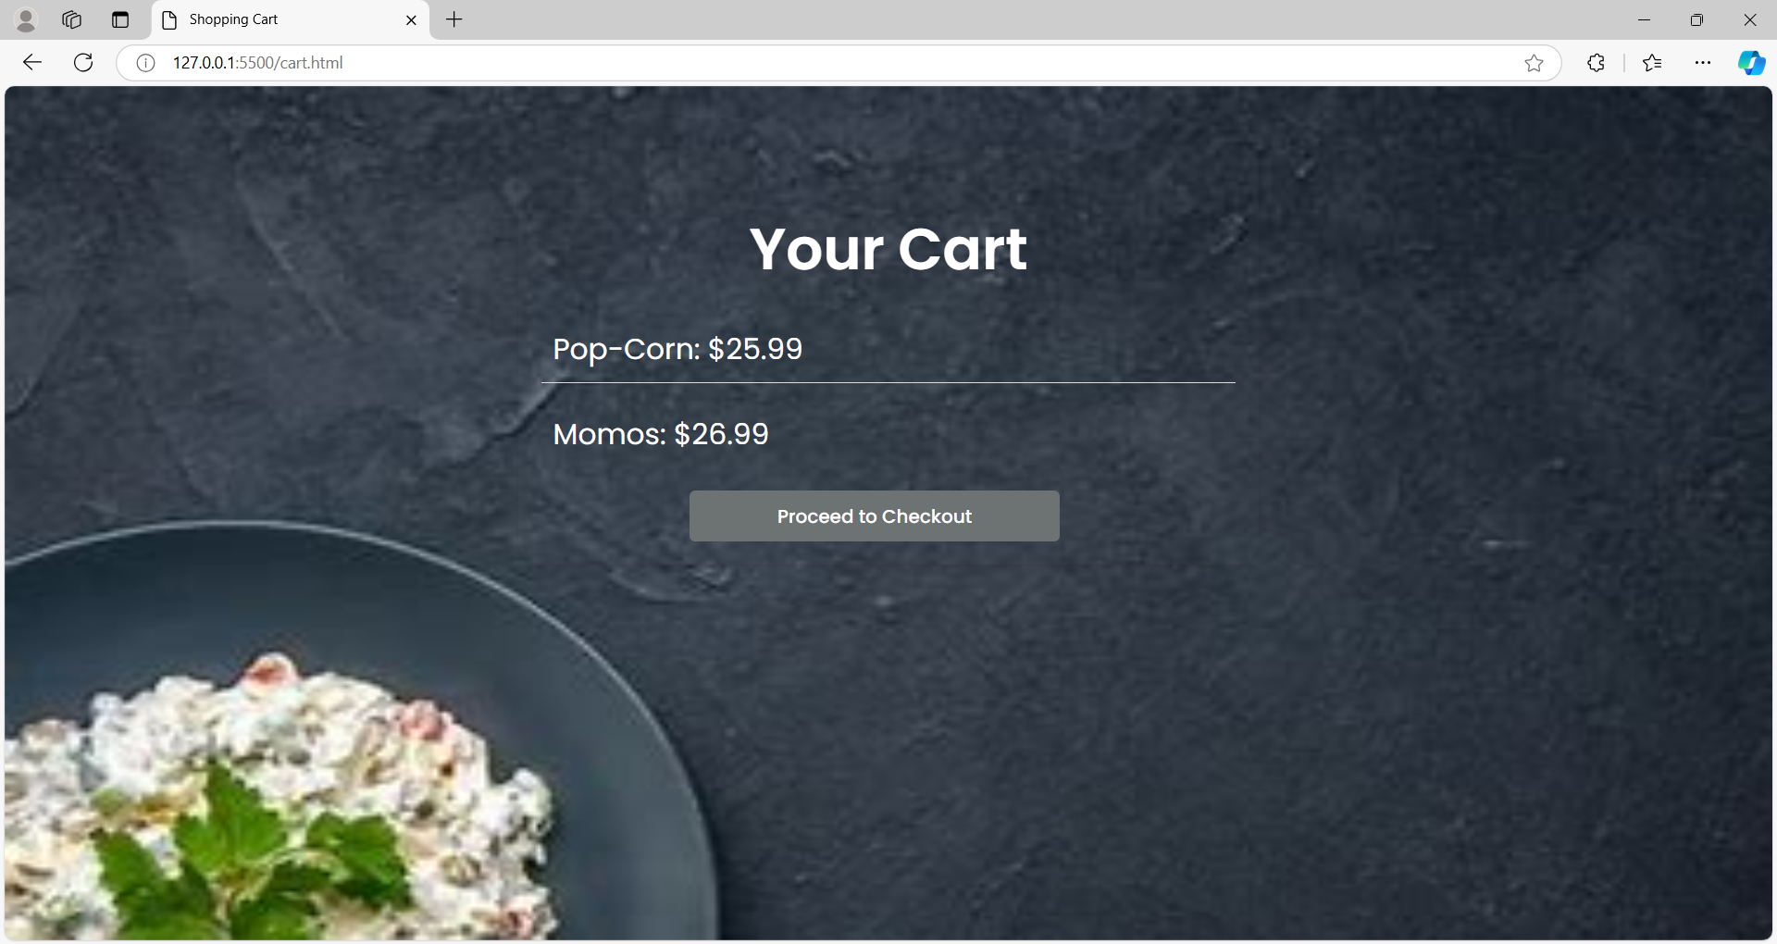

**Billing Page:**

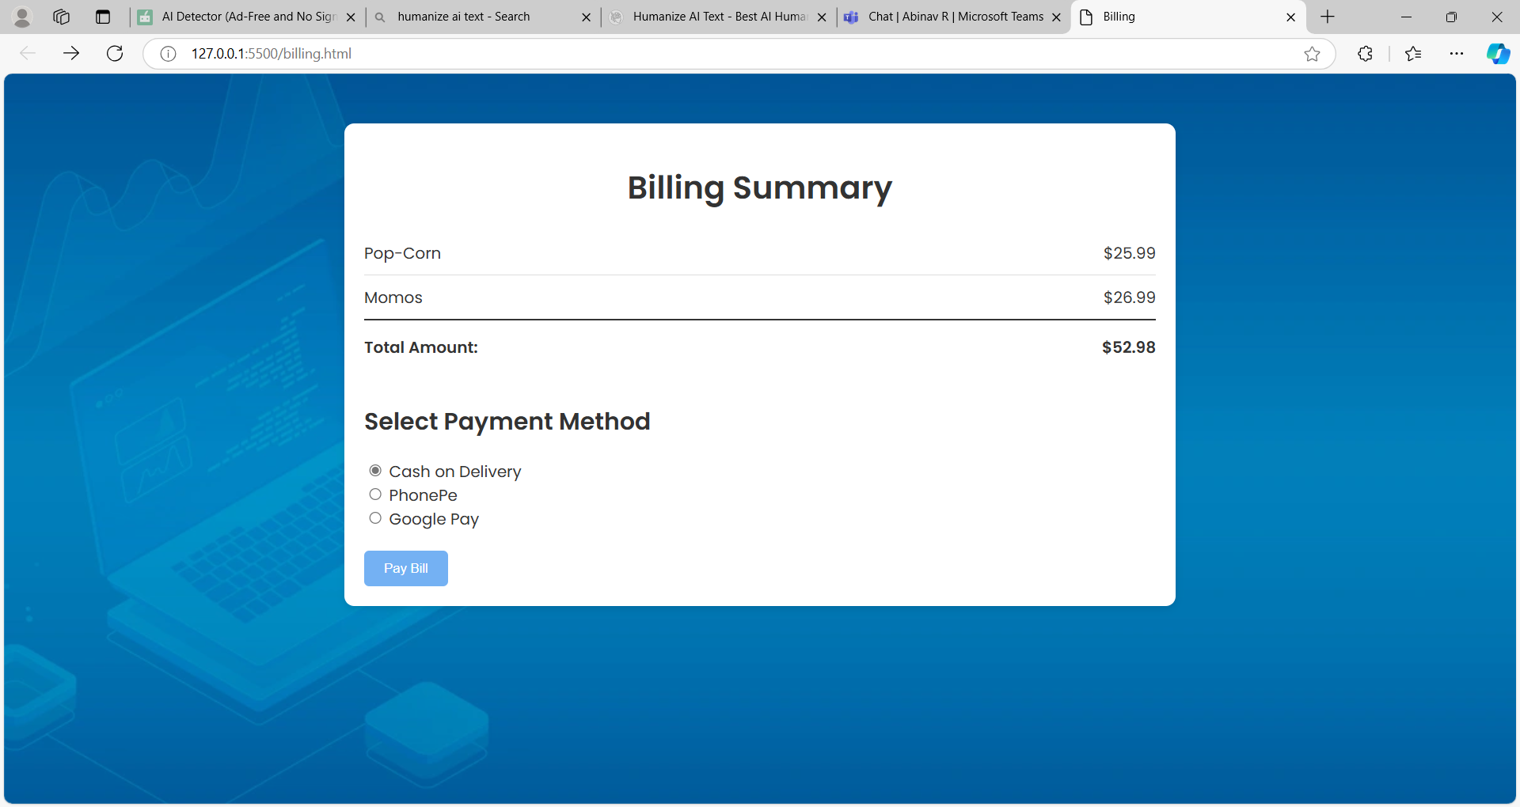

**Admin Login:**

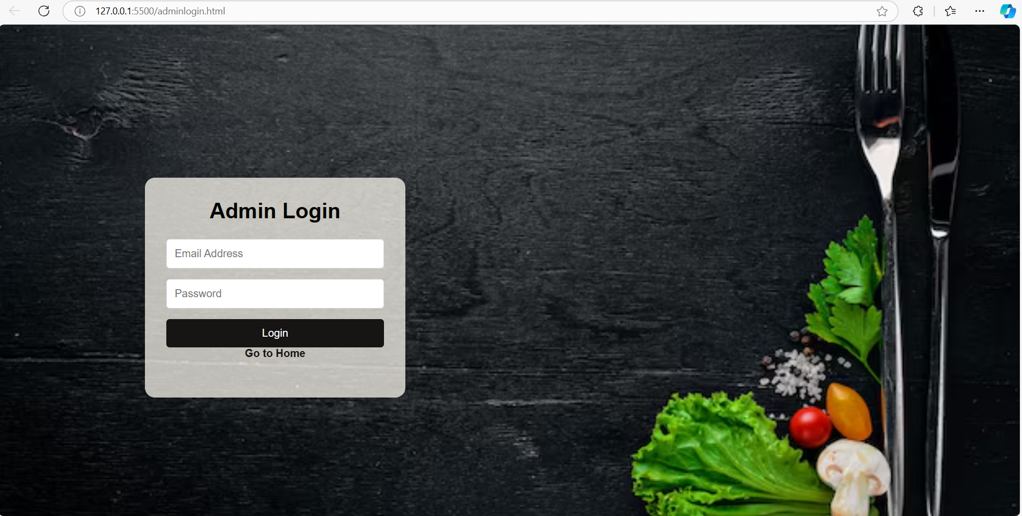

**Order Details:**

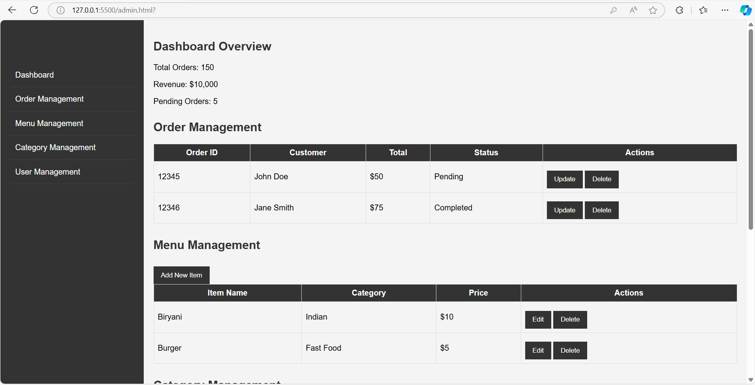

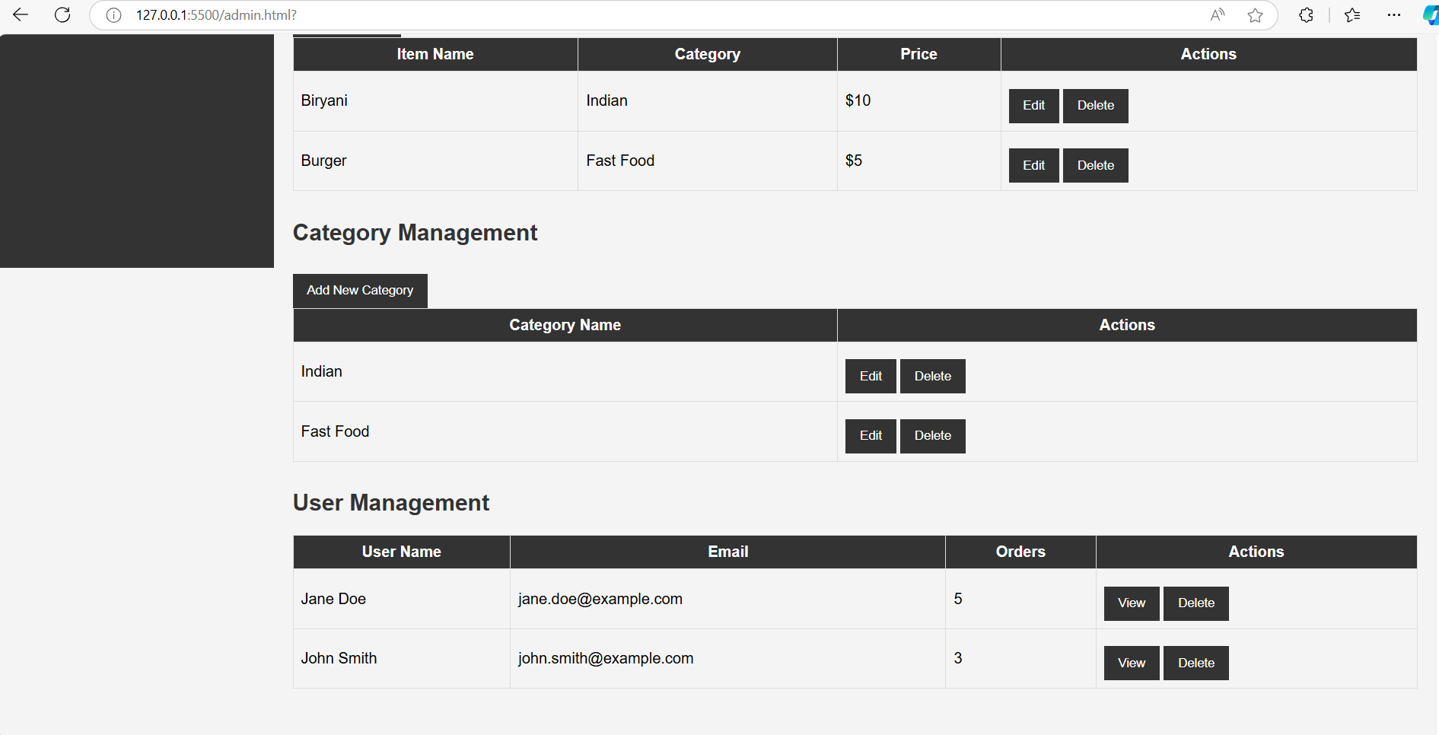

**Logout page:**

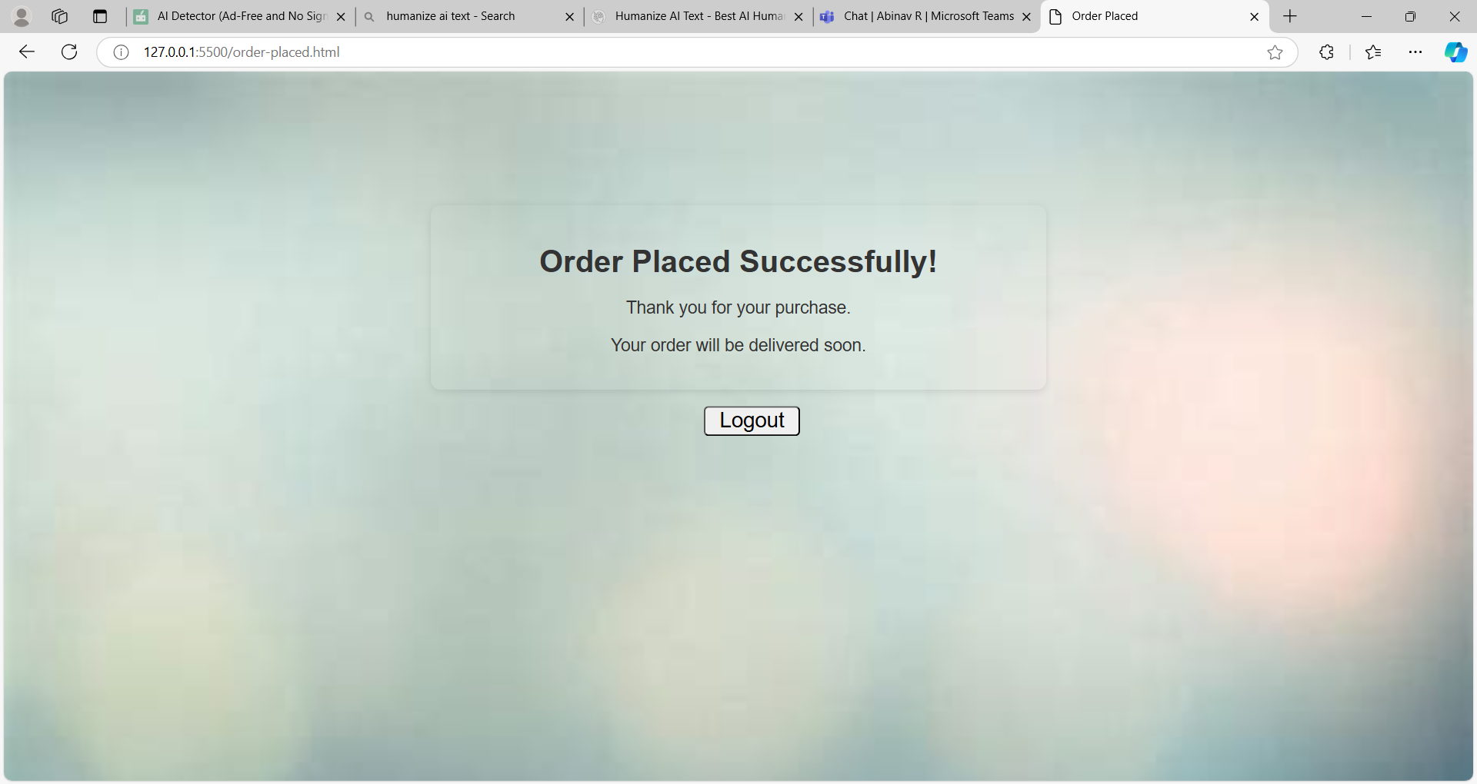

# 5.System Analysis:

The food ordering system even though scrutinized from the customers’ perspective or the restaurants’ is not limited to them as the whole platform upholds its processes and requirements. The interaction consists mostly of an interface, ordering, payment and data bases. The interface should be such that the customers are able to view the available food options, select them and edit their orders without any difficulties. The order management system on the other hand runs in the background managing orders using a systematic process by offering an order to a specific kitchen or restaurant later allowing the customer to see any order in progress and any respective changes to the order over time.

Payment processing is one of the most important components because it allows one to transact and not worry about the loss of money. Therefore, there is a need for fast and reliable payment gateways that will promote the customers’ trust towards access to the services. A system will have to be created to maintain and manage ever growing arrays of records pertaining to customers, menus, orders, stock on hold and stock in use so as to pack and manage stock particularly in a controlled manner.

# 6.Summary:

In conclusion, the evolution of the internet has led to advancements in food ordering systems both for the end user and the restaurant management. It enhances the experience of customers by making it easy and fast to select their preferred meals, further personalized within the available meals. Whereas, it streamlines the processes for the restaurant cutting down order taking and stock monitoring mistakes, thus improving efficiency of restaurant operations. Other functions related to this system encompass the need to engineer the system in a manner that enhances the efficiency of processing sales and sales promotions. To put it briefly, it can be stated that installation and use of online ordering systems can create a competitive edge for any restaurant in the food industry, which is highly dynamic, ever growing, and in most cases, advancing at the farthest ends.

# 7. References and Bibliography:

<https://www.tutorialspoint.com/index.htm>

<https://www.javatpoint.com>

https://www.w3schools.com [https://html.com](https://html.com/)

https://chat.openai.com/c/2683c539-0227-4fe3-983f-6b0151ed18e3

<https://www.google.com/>

https://chatuml.com/edit/new

|  |  |  |
| --- | --- | --- |
| 1. | Is the final report neatly formatted with all the elements required for a technical Report? | YES |
| 2. | Is the Cover page in proper format as given in Annexure A? | Yes |
| 3. | Is the Title page (Inner cover page) in proper format? | Yes |
| 4. | 1. Is the Certificate from the Mentor in proper format? 2. Has it been signed by the Mentor | Yes  Yes |
| 5. | Is the Abstract included in the report properly written within one page? Have the technical keywords been specified properly? | Yes  Yes |
| 6. | Is the title of your report appropriate? The title should be adequately descriptive, precise and must reflect scope of the actual work done. Uncommon abbreviations / Acronyms should not be used in the title | Yes |
| 7. | Have you included the List of abbreviations / Acronyms? | Yes |
| 8. | Does the Report contain a summary of the literature survey? | Yes |
| 9. | Does the Table of Contents include page numbers?  (i). Are the Pages numbered properly? (Ch. 1 should start on Page # 1)  (ii). Are the Figures numbered properly? (Figure Numbers and Figure  Titles should be at the bottom of the figures)  (iii). Are the Tables numbered properly? (Table Numbers and Table  Titles should be at the top of the tables)  (iv). Are the Captions for the Figures and Tables proper? (v). Are the Appendices numbered properly? Are their titles appropriate | Yes      Yes    Yes    Yes  Yes |
| 10. | Is the conclusion of the Report based on discussion of the work? | Yes |
| 11. | Are References or Bibliography given at the end of the Report?  Have the References been cited properly inside the text of the Report? Are all the references cited in the body of the report | Yes  Yes  Yes |
| 12. | Is the report format and content according to the guidelines? The report should not be a mere printout of a Power Point Presentation, or a user manual. Source code of software need not be included in the report. | Yes |

# 8. Declaration by Student

I hereby attest that I have thoroughly checked every aspect of this checklist, and I also make sure that this report is in the correct format as provided in the course pack.

Place: Nagpur

Date: 02-11-2024



Signature of the student

Name: Bejagama Chandana

Id No: 202217b2131